Kubernetes 09

1.Execute all the steps shown in video.
Ingress:
========
Ingress will helps us to expose the applciations and manage external access by providing http/https routing rules to the services within a k8s cluster.
Ingress controller:
==================
Nothing but a load balancer which is responsible for implementing and managing Ingress resources.
We have multiple load balancer in market like
NGINX
A10
F5
Traefik HA PROXY
Ingress is developed by k8s.
Ingress controller is developed by the load balancer companies.
Why should we use Ingress?
prior to ingress we were using load balancer service to expose our application to outside world,but it only provides round robin algorith.
There were couple of issues for applicaitons,
for example if we have 100 services then we need to create 100 services. It will not support different features which our load balancer's were doing.
Like path based routing,rules,whitelisting,blacklisting,tls,sticky session,hostbasedrouting.
To over come the problem Ingress has been introduced to k8s.
What needs to be done by user?
- He needs to create one ingress.
- He needs to create ingress controller based upon the features/capabalities we need.

STEP 1 – Start Minikube
minikube start
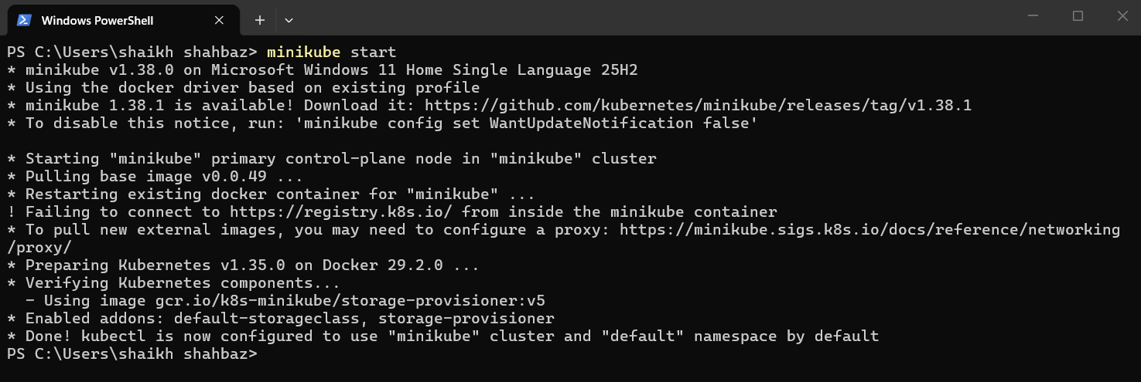
minikube addons enable ingress
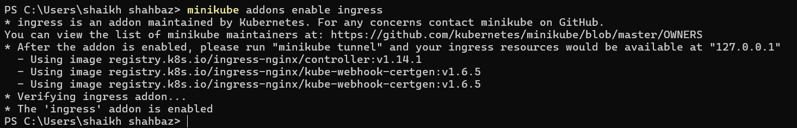

Check ingress pods:
kubectl get pods -A
You must see:
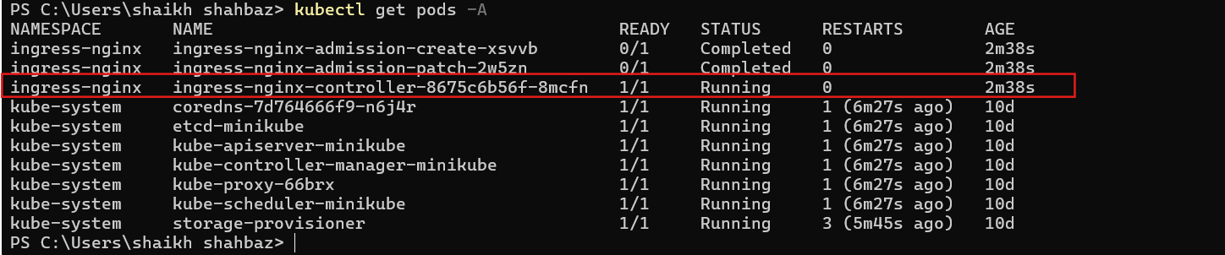

STEP 2 – Create Deployment
vi deployment.yaml
apiVersion: apps/v1
kind: Deployment
metadata:
name: nginx-deployment
spec:
replicas: 1
selector:
matchLabels:
app: nginx
template:
metadata:
labels:
app: nginx
spec:
containers:
- name: nginx
image: nginx:latest
ports:
- containerPort: 80
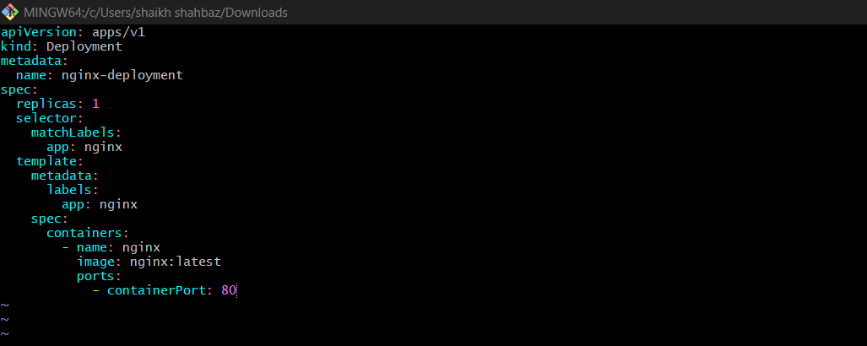
Save and apply:
kubectl apply -f deployment.yaml
kubectl get pods
Wait until:
1/1 Running

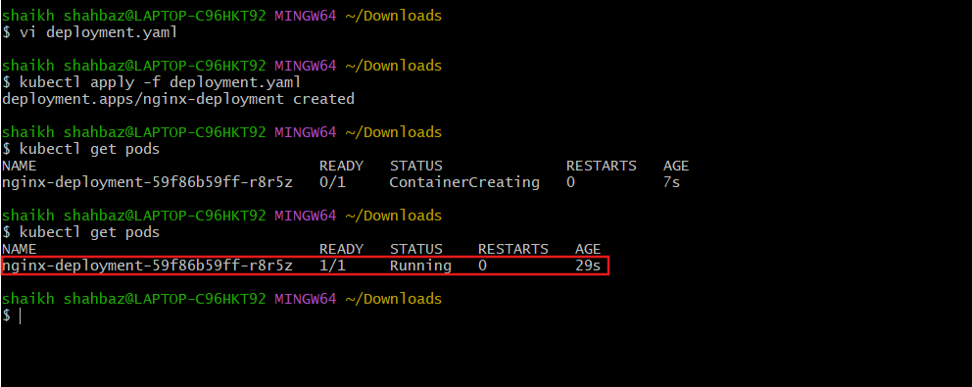

STEP 3 – Create Service (ClusterIP)
Important: For Ingress → use ClusterIP
Create:
vi service.yaml
apiVersion: v1
kind: Service
metadata:
name: nginx-service
spec:
selector:
app: nginx
ports:
- port: 80
targetPort: 80
type: ClusterIP
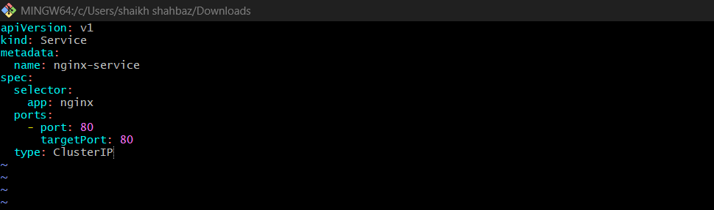
Apply:
kubectl apply -f service.yaml
kubectl get svc
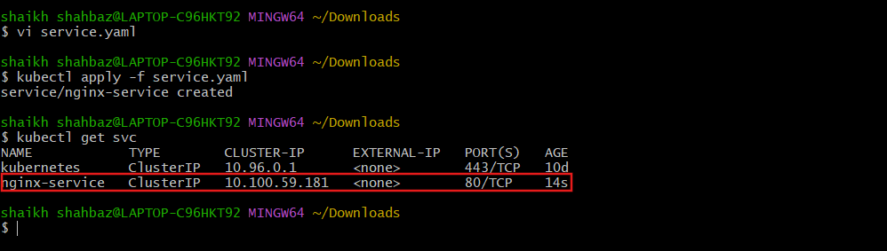

STEP 4 – Create Ingress (Use Your Domain)
Create:
vi ingress.yaml
apiVersion: networking.k8s.io/v1
kind: Ingress
metadata:
name: nginx-ingress
spec:
rules:
- host: nginx.local
http:
paths:
- path: /
pathType: Prefix
backend:
service:
name: nginx-service
port:
number: 80
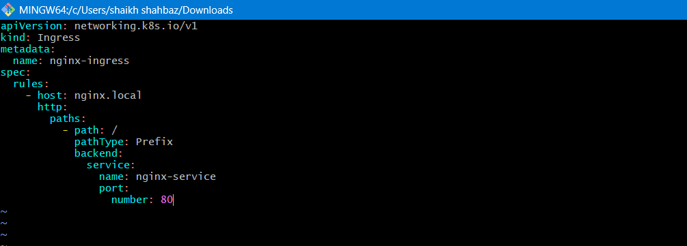

Apply:
kubectl apply -f ingress.yaml
kubectl get ingress
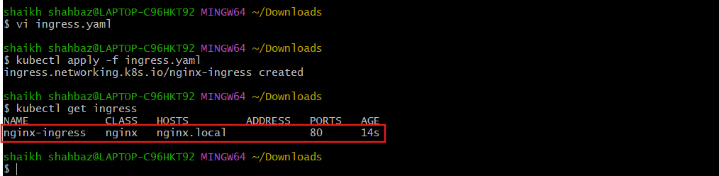

STEP 5 – Start Minikube Tunnel (VERY IMPORTANT)
Run:
minikube tunnel
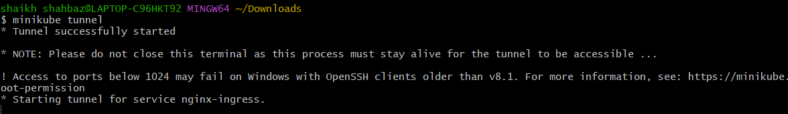
Enter your laptop password
Keep this terminal OPEN
Open new terminal and check:
kubectl get ingress

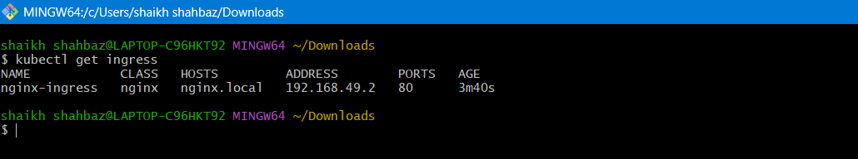

Step 6 - Do This Now (Windows + Git Bash Setup)
Confirm Minikube IP (already correct)
You have:
192.168.49.2

Edit Hosts File (VERY IMPORTANT)
You must open Notepad as Administrator:
- Press Start
- Search Notepad
- Right-click → Run as Administrator
- Click File → Open
- Go to:
C:\Windows\System32\drivers\etc\
- Change file type to All Files
- Open hosts

Add This Line
At the bottom add:
192.168.49.2 nginx.local
Save the file.
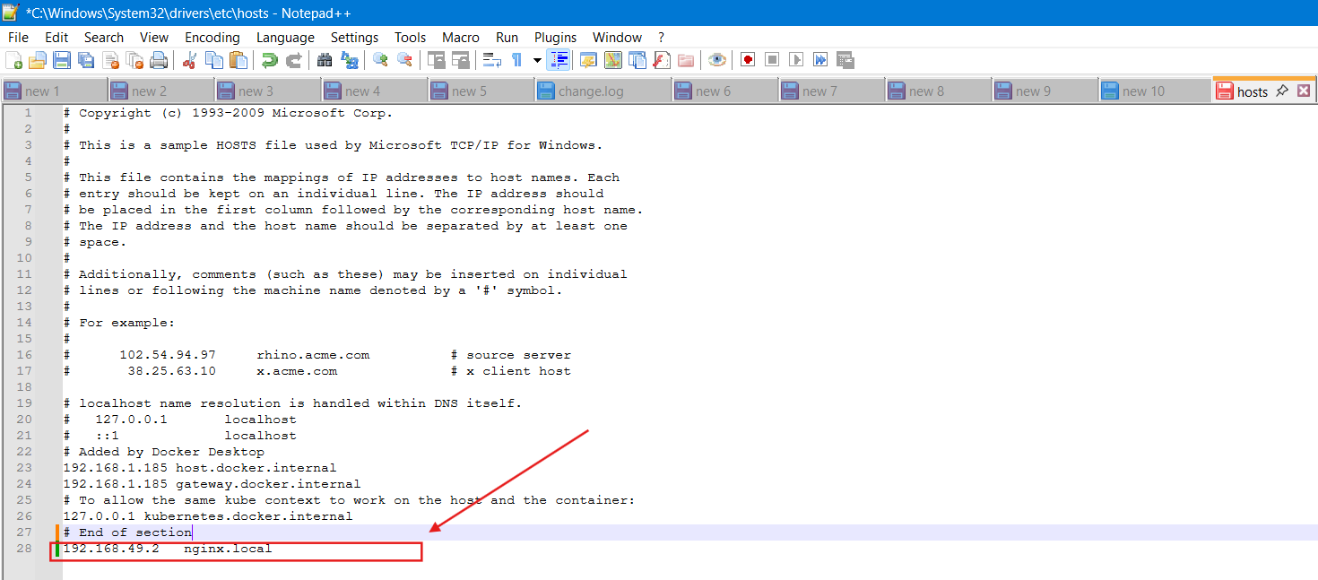
Flush DNS (IMPORTANT)
Open Command Prompt as Administrator and run:
ipconfig /flushdns
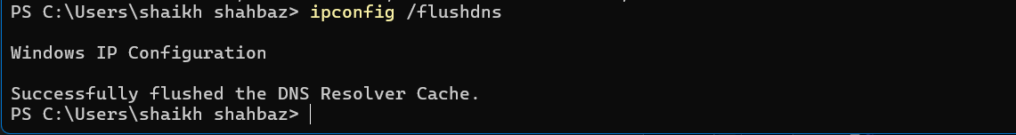
Keep Tunnel Running
Make sure this terminal stays open:
minikube tunnel
It must keep running.
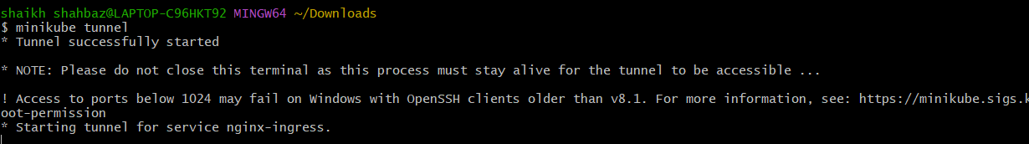
Now Test
Open browser:
http://nginx.local
If It Doesn’t Work
Test directly:
http://192.168.49.2
Now instead of tunnel, run:
minikube service nginx-service

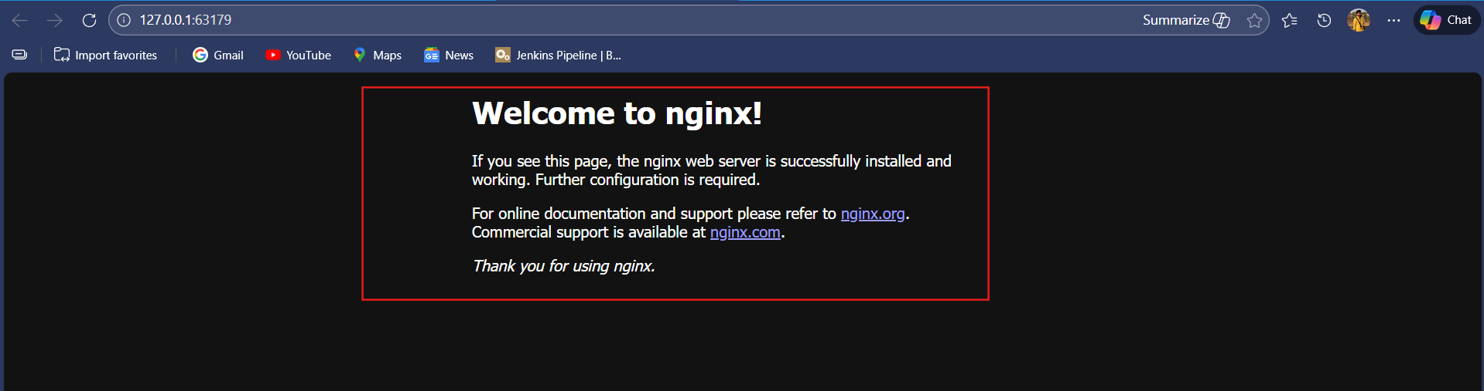

2.Upgrade k8s cluster from 1.29 to 1.30 Version.
Note: Document to upgrade cluster.
https:// devopscube.com/upgrade-kubernetes-cluster-kubeadm/

Upgrade Path: v1.29.15 → v1.30.x
Environment:
- Control Plane: k8s-master
- Worker Node: worker01
- CNI: Calico
- Upgrade Type: Rolling Upgrade (Zero Downtime Method)
- Current Version: v1.29.15
- Target Version: v1.30.x

  - Pre-Upgrade Validation
Before starting the upgrade, cluster health must be verified.

1.1 Check Node Status
kubectl get nodes
✔ Validation:
- All nodes must be Ready
Example:
NAME STATUS ROLES VERSION
k8s-master Ready control-plane v1.29.15
worker01 Ready <none> v1.29.15
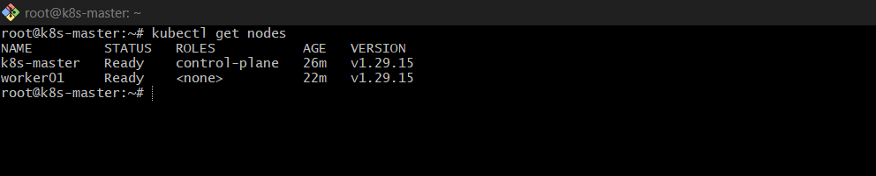
1.2 Check All Pods
kubectl get pods -A
✔ Validation:
- All pods must be Running
- No CrashLoopBackOff
- No Pending pods
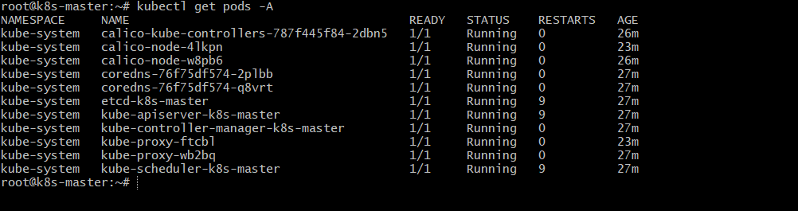
1.3 Verify Current Versions
kubeadm version
kubectl version
✔ Expected:
kubeadm: v1.29.15
Client Version: v1.29.15
Server Version: v1.29.15
All components must be aligned before upgrade.
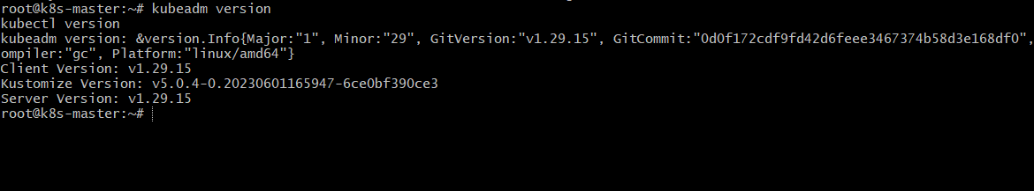
  - Upgrade Control Plane (Master Node)
⚠ Control plane must always be upgraded first.

Step 1 — Update Kubernetes Repository to v1.30
echo "deb [signed-by=/etc/apt/keyrings/kubernetes-aptkeyring.gpg] \
https://pkgs.k8s.io/core:/stable:/v1.30/deb/ /" \
| sudo tee /etc/apt/sources.list.d/kubernetes.list
sudo apt update
Explanation:
Your system was using the v1.29 repository.
To install v1.30 packages, we must change the repository.
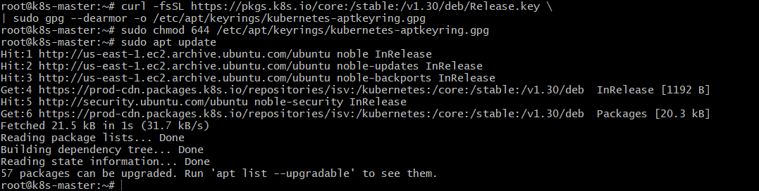
Step 2 — Verify Available Versions
sudo apt-cache madison kubeadm
✔ Validation:
- You should see available versions like 1.30.x-1.1
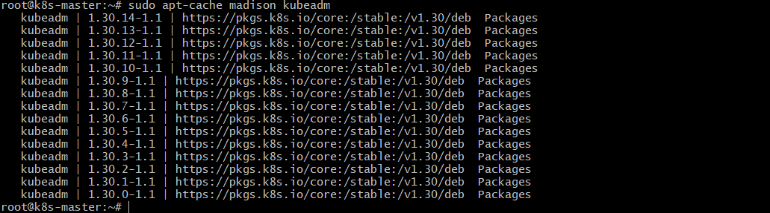
Step 3 — Upgrade kubeadm (Master)
sudo apt-mark unhold kubeadm
sudo apt-get install -y kubeadm=1.30.3-1.1
sudo apt-mark hold kubeadm
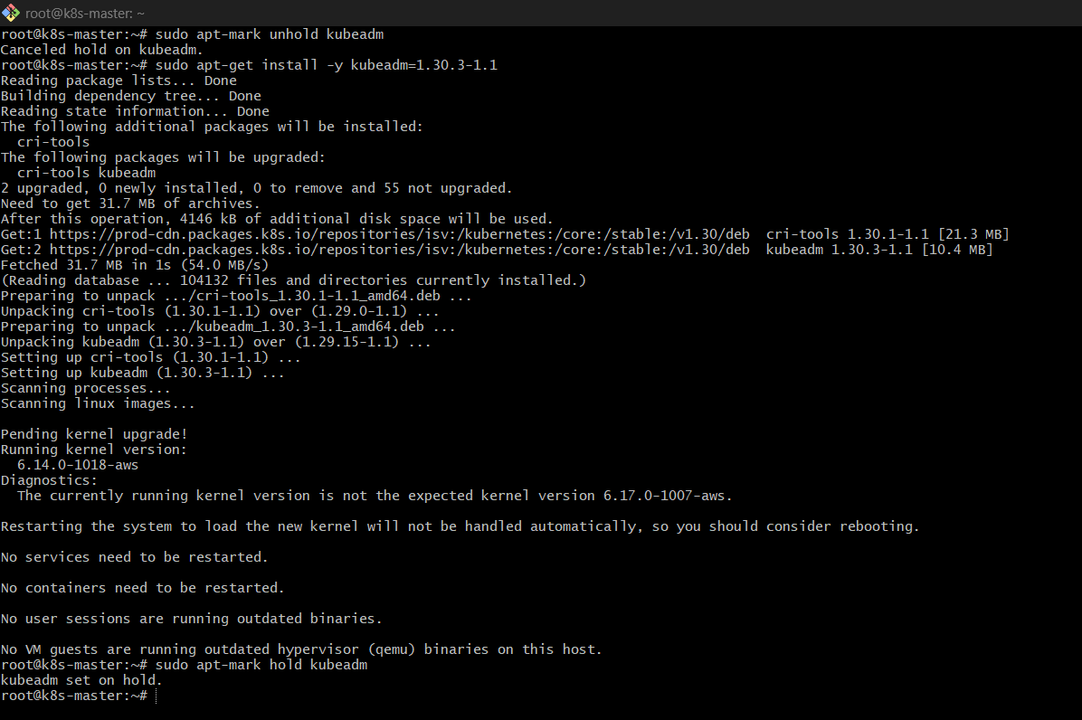
Explanation:
- kubeadm controls cluster upgrade.
- It must be upgraded before applying cluster changes.
- Package is held again to prevent accidental updates.
Verify:
kubeadm version
✔ Expected:
v1.30.x
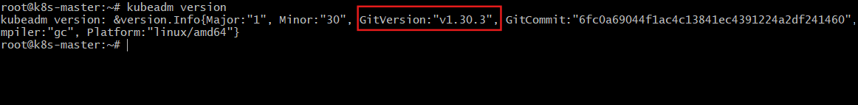
Step 4 — Check Upgrade Plan
sudo kubeadm upgrade plan
Explanation:
This command:
- Validates cluster health
- Checks compatibility
- Shows upgrade target
✔ Validation:
Upgrade to v1.30.x should be displayed without errors.
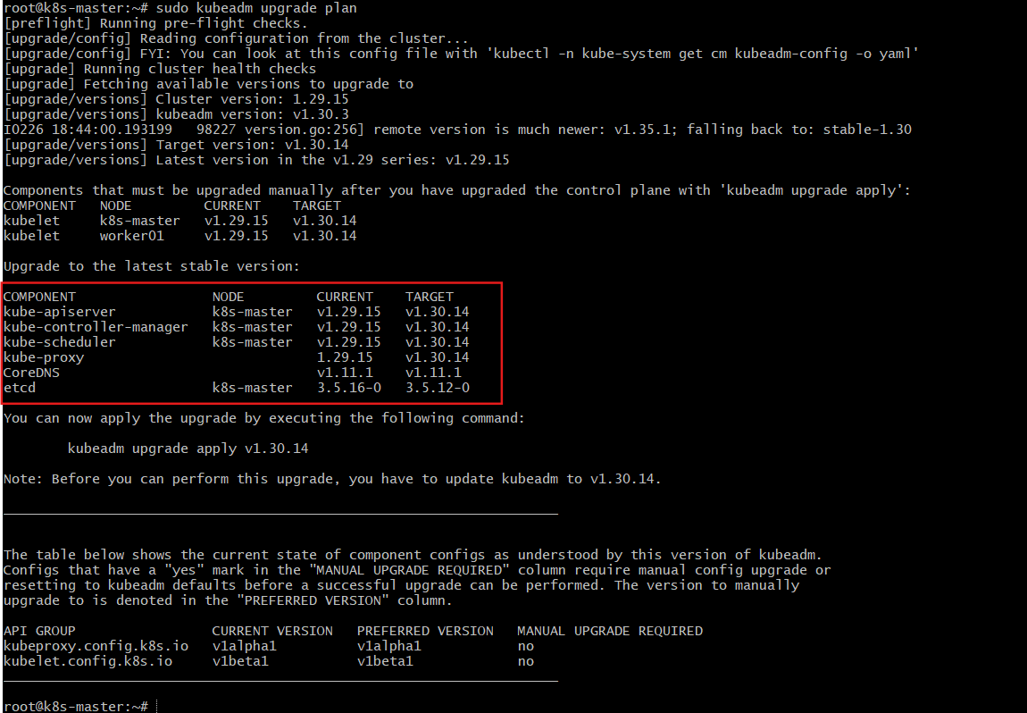
Step 5 — Apply Control Plane Upgrade
sudo kubeadm upgrade apply v1.30.3
Type y when prompted.
What This Does:
- Upgrades kube-apiserver
- Upgrades controller-manager
- Upgrades scheduler
- Upgrades etcd (if required)
- Updates cluster configuration
Wait until upgrade completes successfully.
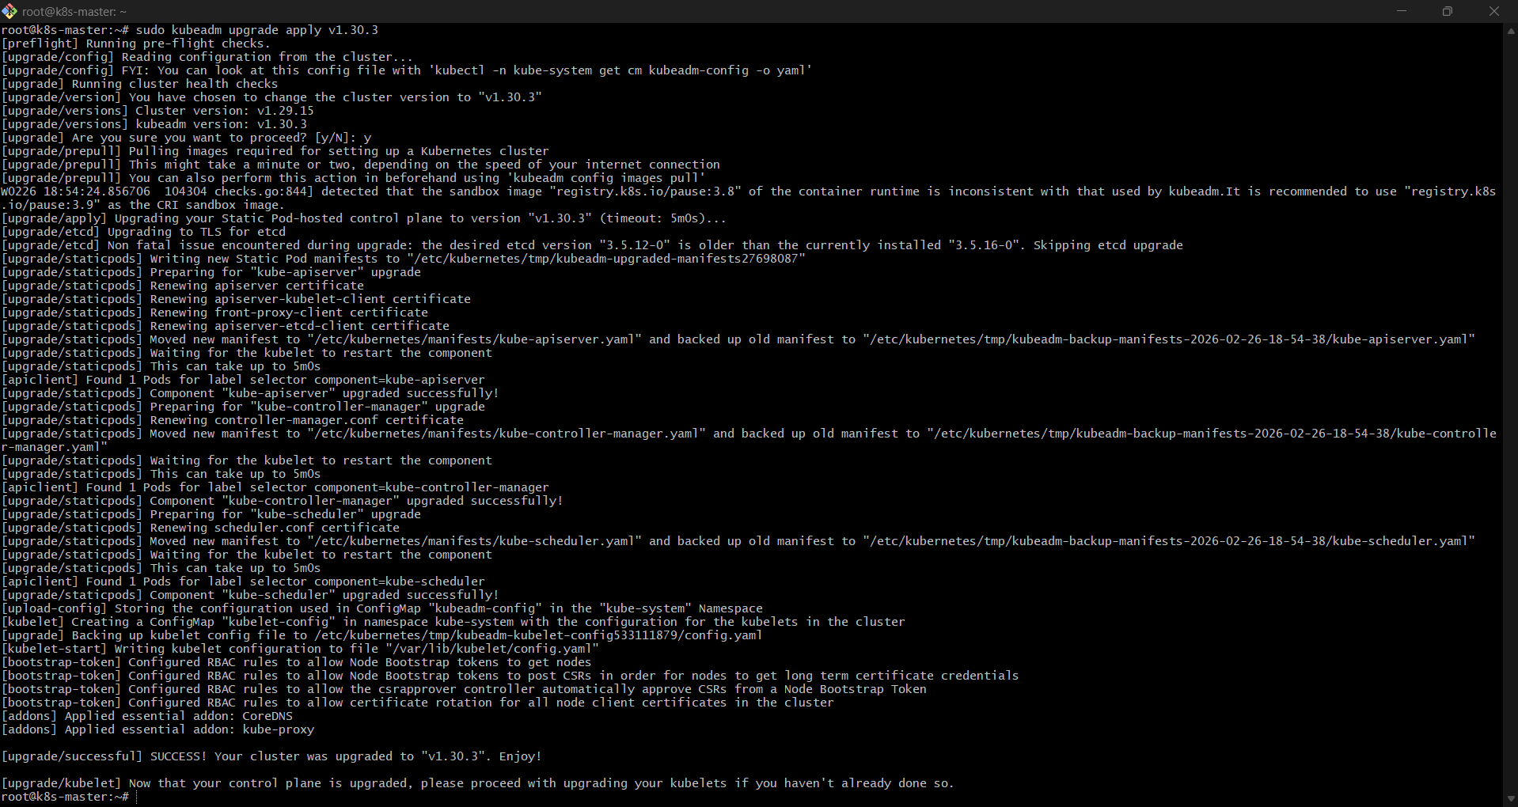
Step 6 — Upgrade kubelet & kubectl (Master)
sudo apt-mark unhold kubelet kubectl
sudo apt-get install -y kubelet=1.30.3-1.1 kubectl=1.30.3-1.1
sudo apt-mark hold kubelet kubectl
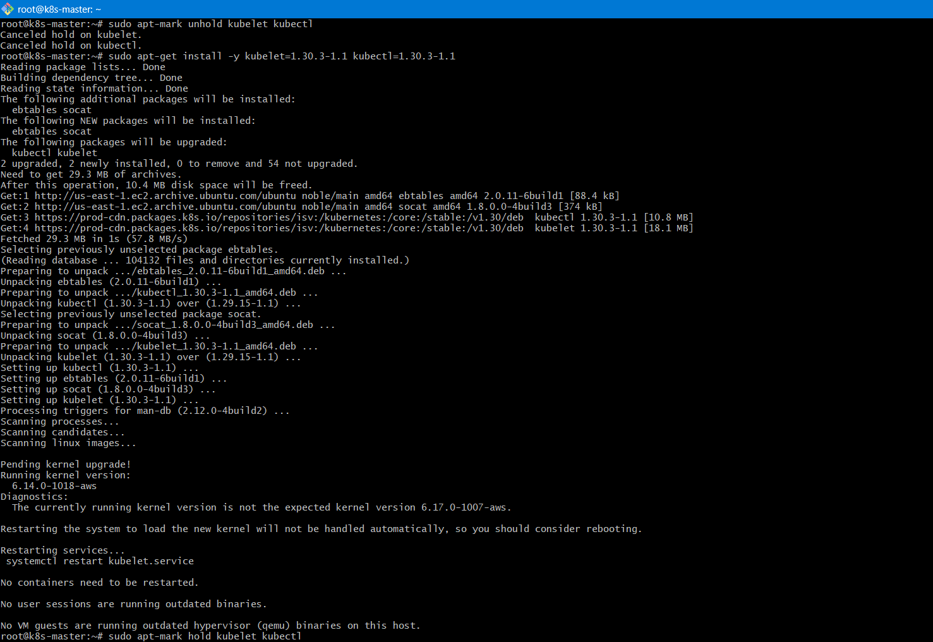
sudo systemctl daemon-reload
sudo systemctl restart kubelet
Explanation:
- kubeadm upgraded control plane components.
- Now node binaries (kubelet & kubectl) must match the new version.
- Restart activates new version.

Step 7 — Validate Master Upgrade
kubectl get nodes
✔ Expected:
NAME STATUS ROLES VERSION
k8s-master Ready control-plane v1.30.x
worker01 Ready <none> v1.29.15
Master successfully upgraded.
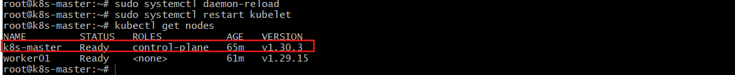
  - Upgrade Worker Node (worker01)

Step 1 — Drain Worker Node
Run on MASTER:
kubectl drain worker01 --ignore-daemonsets --delete-emptydir-data
Explanation:
- Safely evicts workloads
- Prepares node for upgrade
- Ignores daemonsets (like kube-proxy)
🔹 Step 2 — Update Repository on Worker
Login to worker01:
echo "deb [signed-by=/etc/apt/keyrings/kubernetes-aptkeyring.gpg] \
https://pkgs.k8s.io/core:/stable:/v1.30/deb/ /" \
| sudo tee /etc/apt/sources.list.d/kubernetes.list
sudo apt update
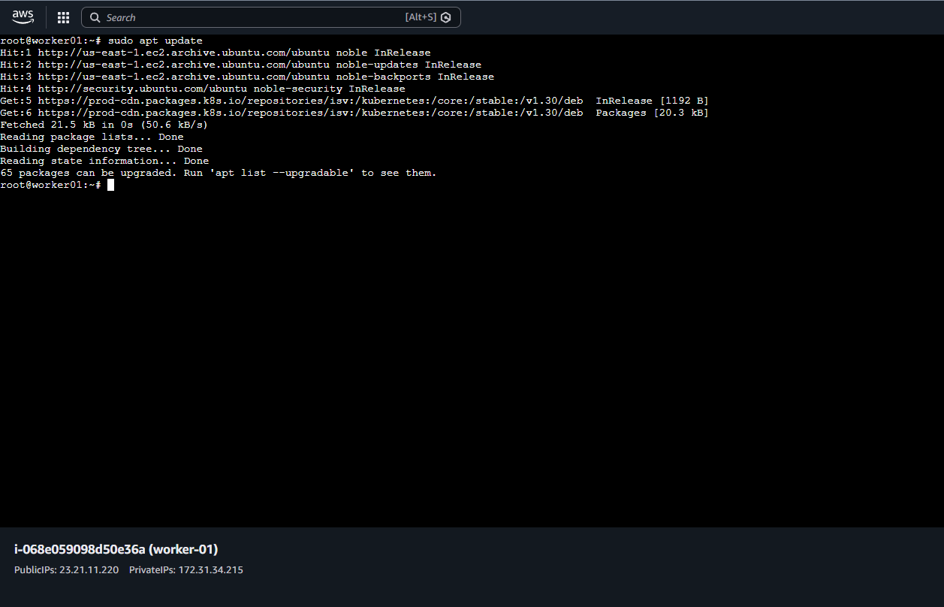
Step 3 — Upgrade kubeadm (Worker)
sudo apt-mark unhold kubeadm
sudo apt-get install -y kubeadm=1.30.3-1.1
sudo apt-mark hold kubeadm
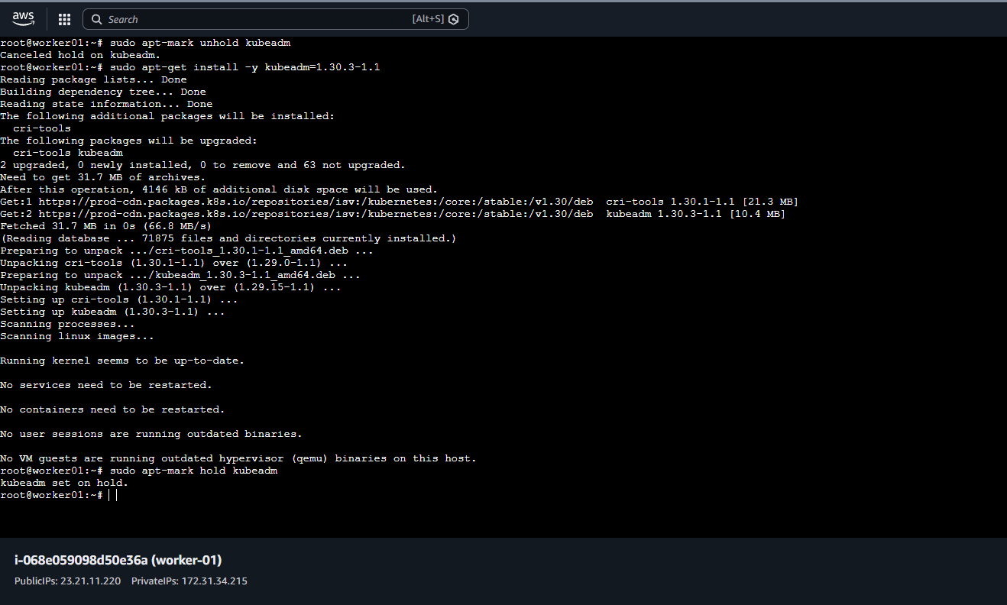
Then run:
sudo kubeadm upgrade node
Explanation:
- Updates worker node configuration
- Syncs worker with control plane
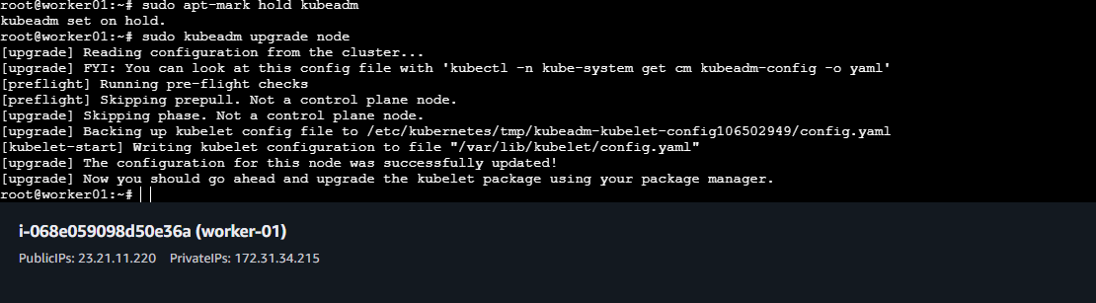
Step 4 — Upgrade kubelet & kubectl
sudo apt-mark unhold kubelet kubectl
sudo apt-get install -y kubelet=1.30.3-1.1 kubectl=1.30.3-1.1
sudo apt-mark hold kubelet kubectl
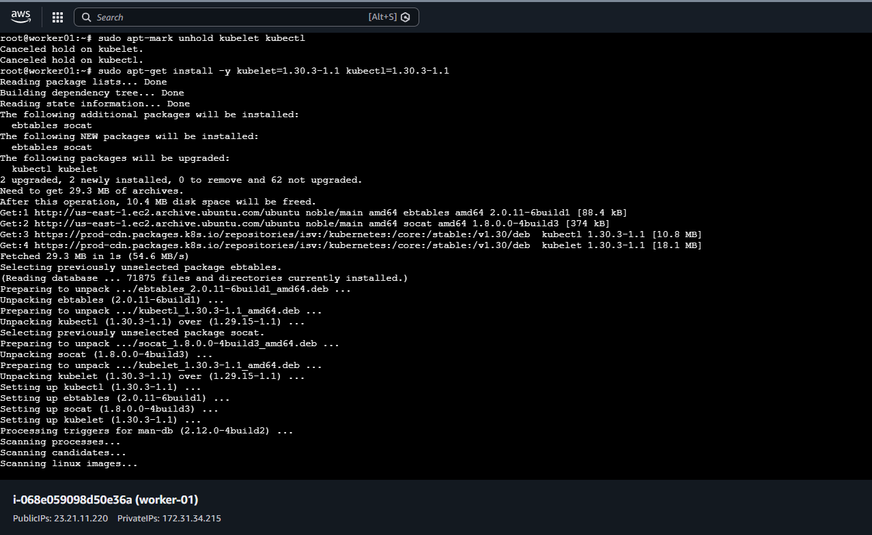
sudo systemctl daemon-reload
sudo systemctl restart kubelet
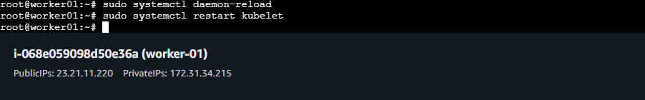
🔹 Step 5 — Uncordon Worker
Back on MASTER:
kubectl uncordon worker01
Explanation:
Allows workloads to schedule again.
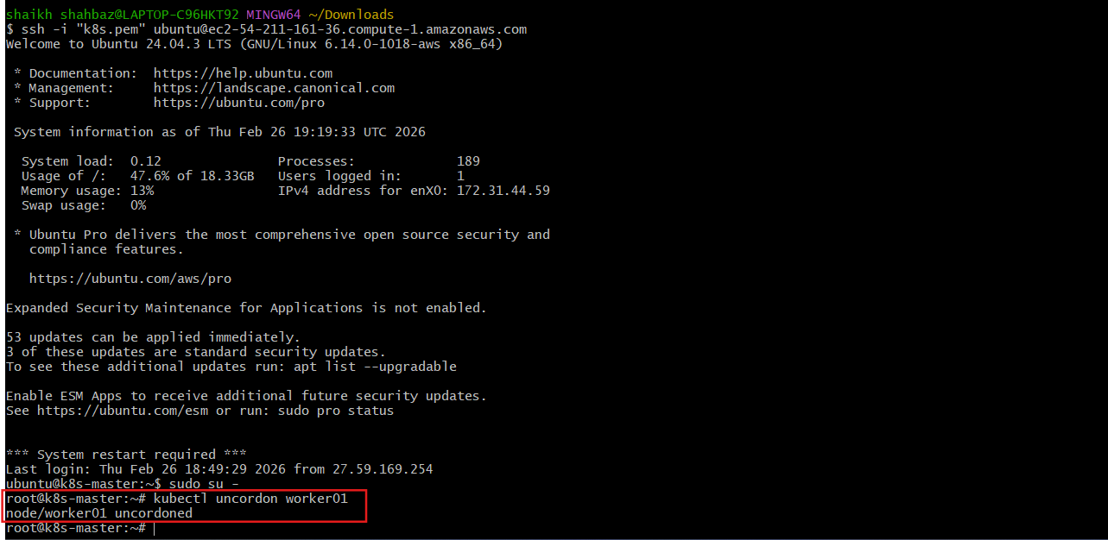
  - Final Validation

4.1 Check Node Versions
kubectl get nodes
✔ Expected:
NAME STATUS ROLES VERSION
k8s-master Ready control-plane v1.30.x
worker01 Ready <none> v1.30.x
4.2 Check System Pods
kubectl get pods -n kube-system
✔ All pods must be Running.
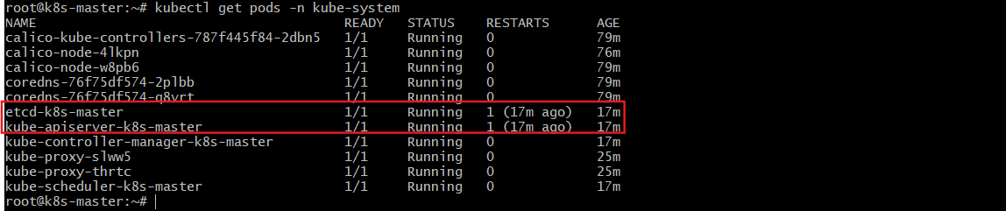
🔹 4.3 Check API Server Health
kubectl get --raw='/readyz?verbose'
✔ Expected Output:
ok
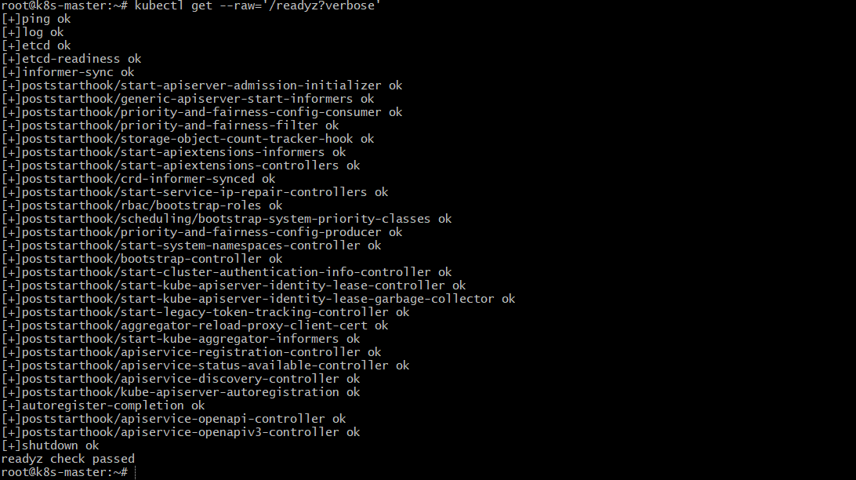
4.4 Check Entire Cluster
kubectl get pods -A
✔ Validation Criteria:
- No CrashLoopBackOff
- No ImagePullBackOff
- No Pending pods
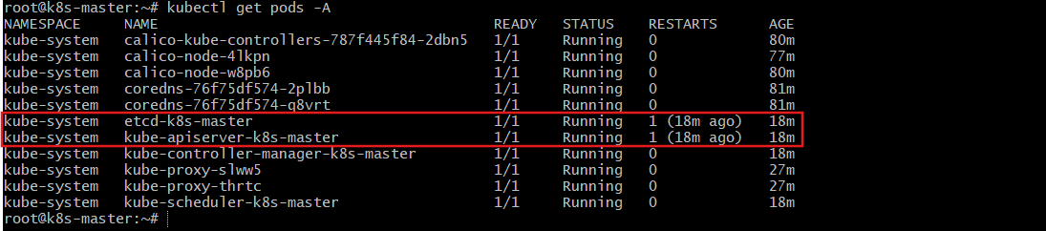
🎯 Final Outcome
✔ Control Plane upgraded from v1.29.15 to v1.30.x
✔ Worker node upgraded to v1.30.x
✔ kubeadm, kubelet, kubectl versions aligned
✔ Rolling upgrade completed
✔ Cluster fully healthy
✔ Zero downtime achieved

